**V- CREATION OF K8S NEW USER WITH PERMISSIONS TO CREATE, LIST, GET, UPDATE AND DELETE PODS.**

**-Application Configuration on the Pods**

**-Snapshot on ETCD Database**

**-Criteria for autoscaling**

For a user to have permissions to create, list, get, update and delete pods we need the following requirements:

Basic level of understanding of [how Kubernetes works](https://kubernetes.io/docs/concepts/).

[Kubernetes](https://kubernetes.io/) cluster or [Minikube](https://kubernetes.io/docs/setup/minikube/) running.

[Kubectl command line](https://kubernetes.io/docs/tasks/tools/install-kubectl/) installed.

[OpenSSL](https://wiki.openssl.org/index.php/) installed.

In our previous installation on (III), we have k8s and kubectl installed. I just install OpenSSL.

https://github.com/jeanmd1/OpenSSL.git

Let’s make sure k8s clusters up and running.

Let’s create a namespace test for a role developer and associate the user jean

Kube configuration files certificate-authority-data

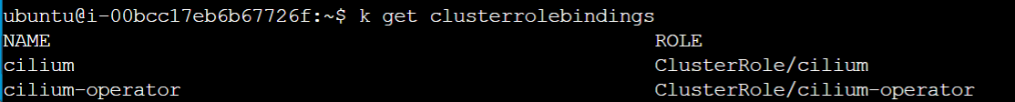

Jean has now permissions to create list get update and delete pods

SNAPSHOT OT ETCD Database

CRITERIA SETTING FOR MEMORY OF CPU

